BEST MANAGEMENT PRACTICES GUIDEBOOK FOR SPECIAL EVENT-GENERATED WASTE
IN RURAL COMMUNITIES

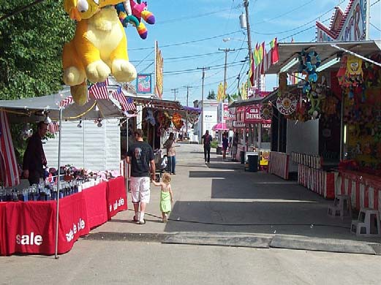

Bath Heritage Days, Maine HCS Flower Show, New Hampshire

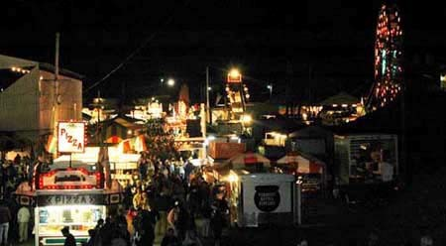
Tunbridge World’s Fair, Vermont

Produced by the Northeast Recycling Council, Inc.
© July 2006

With funding from the United States Department of Agriculture Rural Development Solid Waste Management Grant Program

Table of Contents

Acknowledgements 4
Introduction 5
- Understanding Waste Reduction Strategies 6
  - Reduce 6
  - Reuse 7
  - Recycle 7
  - Compost 7
  - Handling Special Waste 8
- Getting Started – Understanding Recycling Program Details 9
  - Planning for Success 9
  - Understanding Existing Conditions 9
  - Targeting the Waste Stream 10
    - PAPER PRODUCTS 10
    - BOTTLES AND CANS 11
    - ORGANIC WASTE 12
    - BULKY WASTE 13
    - OTHER WASTE 13
  - The Dollars and Cents of Waste Management 14
    - COSTS 14
    - REVENUE/SAVINGS 14
  - Estimating the Environmental Benefits of Recycling 15
- The Nitty Gritty – Organizing Recycling Program Details 15
  - Getting Commitment from the Top 15
  - Designating a Point Person / Steering Committee 16
  - Creating a Realistic Plan 16
  - Negotiating with Haulers 18
  - Dealing with Event Vendors 19
    - STRATEGIES FOR VENDOR PARTICIPATION 19
    - COMMUNICATION IS THE KEY 20
  - Equipment and Containers 20
- Staff and Volunteers 22
- Leveraging Partnerships 23
- Event Management and Evaluation – Implementing the Plan & Taking a Look Back 24
  - Point Person 24
  - Set Up 24
  - During the Event 24
  - After the Event 24
  - Publicity and Education 25
  - Frequently Asked Questions 26
APPENDICES 28
Appendix A: Selected Events Summary 29
    - SELECTED EVENT PROFILES 29
    - SELECTED EVENTS’ WASTE GENERATION 31
Appendix B: Recycling Planning Work Sheet 33
Appendix C: Recycling Budget Form 35
Appendix D: Helpful Resources and Links 36
- SPECIAL EVENTS WITH ESTABLISHED RECYCLING PROGRAMS 36
- USEFUL WASTE CONVERSION FACTORS 36
Appendix E: Sample Recycling Sign 37
Appendix F: Sample Press Release 38

Acknowledgements
The Northeast Recycling Council, Inc. (NERC) would like to express its sincere appreciation to the many individuals and organizations who contributed to the development of the Best Management Practices Guidebook for Special Event-Generated Waste in Rural Communities. NERC would also like to extend a special thank you to the USDA for funding this project through its Rural Utility Services, Solid Waste Management Grant program.

During the development of the project, a team of individuals from state and local government in Maine, New Hampshire, and Vermont, as well as the event coordinators from the six participant special events, provided ongoing input, assistance, and support for this initiative. In particular, we would like to thank:

Maine
- George McDonald, Maine State Planning Office
- Bruce White, Maine State Planning Office
- Mari Eosco, Bath Main Street Program
- Leslie Trundy, Bath Main Street Program
- Paula Adam, Bath Waste Management District
- Jon Whitten, Clinton Lions Club Fair and the Maine Association of Fairs
- Don Harrington, Clinton Lions Club Fair and the Maine Association of Fairs

New Hampshire
- Donald Maurer, New Hampshire Department of Environmental Services
- Sharon Yergeau, New Hampshire Department of Environmental Services
- Bob Silk, Cheshire Fair Grounds and New Hampshire Association of Fairs and Exhibitions
- Joe Sears, Deerfield Agricultural Fair
- Steven Curtin; Home, Healthcare, Hospice & Community Services (HCS) Development Office
- Megan Burke Kidder, HCS Flower Show Committee Chair
- Tim Parsons, New Hampshire Municipal Association

Vermont
- Carolyn Grodinsky, Vermont Agency of Natural Resources
- Kate Barash-Engel, Association of Vermont Recyclers
- Erin Croom, Association of Vermont Recyclers
- Krista Harness, Association of Vermont Recyclers
- Donna Casey, Central Vermont Solid Waste Management District
- Tim Cianciola, Craft Producers, Inc.
- Joyce Majors, Lamoille County Solid Waste Management District
- Rebecca Begoin, Tunbridge Fair Association
- Euclid Farnham, Tunbridge Fair Association

NERC would like to thank Peter Allison and DSM Environmental Services, as the project consultants, for assisting NERC with the implementation of the pilot project and the development of the Guide.

Introduction
Agricultural fairs, heritage days, flower and animal shows, and other special events are important occasions for thousands of rural communities across the United States each year. These events showcase unique aspects of the host town or village, and represent one of the few opportunities when residents and businesses can come together to celebrate what makes their community special.
One element of these events that is often taken for granted is the amount and management of solid waste generated in the days leading up to, during, and at the close of the event. Special events in the United States generate hundreds of thousands of tons of waste each year. For event organizers, managing this waste (otherwise known as refuse, garbage, or trash) can represent a significant cost, consume many volunteer or staff hours, and presents problems with unsightly litter and nuisances. Much of this material can be recycled or composted, or avoided altogether. In addition to the specific economic and environmental benefits of reducing the amount of waste going to disposal, special events are an ideal forum for promoting recycling by demonstrating that recycling is possible wherever you are.

Fortunately, there are many ways that event organizers can dramatically reduce the amount of waste that ends up being disposed of as trash. In addition to reducing nuisances, proactive waste reduction and recycling¹ strategies are good for the environment. They lessen the environmental impacts associated with landfill water discharges and incinerator air emissions from disposed trash, and conserve resources that go into making new products by providing recycled material for manufacturing. Further, recycling efforts also send a positive message to event attendees, staff, and volunteers that it is possible to be good environmental stewards when away from home or work.

The Best Management Practices Guidebook for Special Event-Generated Waste in Rural Communities (Guidebook) is intended to help event organizers and individuals responsible for event waste management that are already considering developing or expanding source reduction and recycling programs. The Guidebook was developed by the Northeast Recycling Council, Inc. (NERC) with funding from the United States Department of Agriculture’s Rural Development Solid Waste Management Grant program.

The Guidebook is the result of over a year working with event organizers, state and local recycling officials, and other partners in Maine, New Hampshire, and Vermont to test a variety of recycling strategies at six special events in rural communities. In each state, one of these events was an agricultural fair. The other recycling pilots were implemented at a flower show, a heritage day, and a crafts fair. For each of these events, a planning team conducted site visits with event organizers, gathered data on past solid waste management activities, and developed a Recycling Plan that included recommendations for reducing waste at the 2005 event.² Following is a list of the events.

- Bath Heritage Days, Maine
- Clinton Lions Club Agricultural Fair, Maine
- Deerfield Agricultural Fair, New Hampshire
- HCS Flower Show, New Hampshire
- Stowe Celebrates Summer, Vermont
- Tunbridge World’s Fair, Vermont

¹ For simplicity, the term “recycling” will be used generically in this Guide. Unless otherwise noted, “recycling” will include waste reduction, materials reuse, recycling, and composting.
² A summary of the events and major findings, as well as the web links to the selected events’ detailed Recycling Plans, are included in Appendix A.

During or after each event, a waste characterization analysis of material to be disposed of or recycled was conducted. These analyses involved the hand sorting of hundreds of pounds of trash to analyze the major components of the waste, by type. Based on the collected data, observations at the events, and communications with event organizers, revised recommendations were presented to each event organizer for further developing their event’s Recycling Plan for 2006.

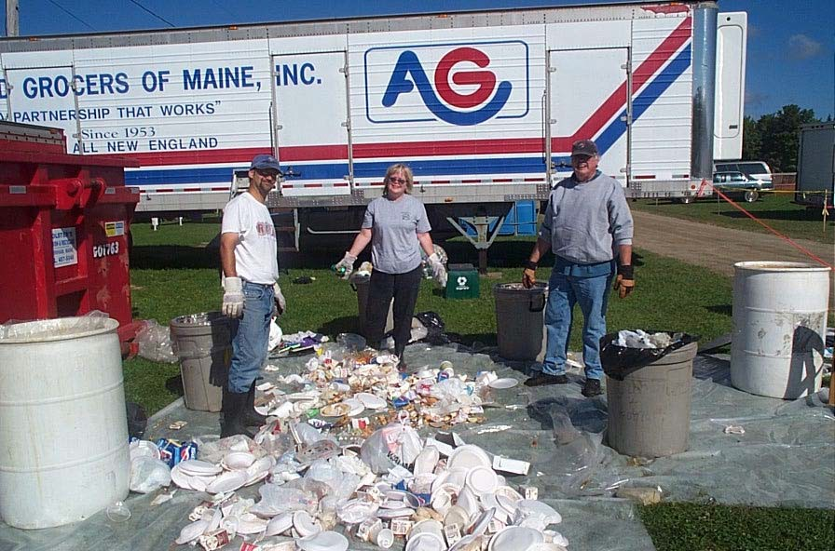
These studies informed the more generalized suggestions in this Guidebook and, in many cases, are referenced as examples in the text. This Guidebook is intended as a mentoring document to be actively used by event organizers in rural communities around the country, and to serve as a launching point for new ideas and suggestions. If you have any comments or suggestions for expanding the scope and possible use of this document, please send them to Mary Ann Remolador of NERC at maryann@nerc.org.
Waste Sort at Clinton Lions Club Agricultural Fair, Maine

Understanding Waste Reduction Strategies
Much of the materials generated at special events can be recycled or composted, or avoided altogether. In addition to the specific economic and environmental benefits of reducing the amount of waste going to disposal, special events are an ideal forum for promoting recycling by demonstrating that recycling is possible wherever you are.
Listed in the order of environmental priority, reduce, reuse, recycle, and composting are the elements of a well established “waste reduction hierarchy”.

Reduce
For special event organizers, identifying practical ways to reduce the amount of waste going to disposal is the key objective. Reducing the amount of waste generated at an event for disposal is the most effective way to cut waste costs and provide environmental benefits. Waste reduction strategies include:

    - Limit or eliminate trash disposal services for vendors. Often vendors pack up in a hurry and leave behind all types of items (e.g., rugs, broken lawn chairs, crushed coolers, old display racks, and old products), leaving the event organizers with the problem of clean-up and disposal costs. Put a clause in the vendor contracts that requires them to pack out all waste, or limits the types of allowable waste. Charge a penalty to all who don’t comply.
    - Encourage or require vendors to supply drinks in containers that can be recycled as part of the event’s recycling program.
    - Limit the number of printed materials, if experience indicates there are usually extras.
    - Be sure that any printed materials are two-sided and on recycled-content paper.
    - Consider requiring that vendors use compostable plates, cups, flatware, and trash bags.

Reuse
    - Choose reusable signs, recycling containers, and other equipment that can be stored for re-use in future years.
    - Encourage and facilitate vendor efforts to donate leftover items, such as food or durable products.

Recycle
Cardboard – Set up a designated, covered storage area for non-waxed cardboard. A dumpster in which vendors and event staff and volunteers can place flattened cardboard boxes is ideal. At some smaller events, cardboard can be transported by staff or volunteers to municipal recycling centers. This option must be negotiated with the town’s recycling program prior to dropping off materials. For larger events, it makes sense to contract with a recycling company or waste hauler to provide the container and take the cardboard for recycling.

Paper – The majority of recyclable paper will be event promotional materials (e.g., fliers, newsletters, and maps) discarded by event-goers or as the result of over production. Setting up paper recycling can be challenging, because it is critical for paper to stay dry and not be mixed with food waste, plastic, or other refuse. Small, specially-marked containers near the exits are one strategy for capturing these materials.

Returnable Cans and Bottles - These are a very valuable commodity in states with Bottle Bills. As such, special effort should be made to capture these containers. It may be possible to partner with a local organization, charity, or company to run the returnable recycling program. Some events even charge recycling companies a fee for the privilege of collecting all the returnable containers. These types of arrangements can reduce the event organizers’ efforts, support local jobs, and get the material out of the waste stream.

Other Recyclable Food & Beverage Containers - Aluminum, glass, steel, and plastic cans and bottles should be collected in designated containers with clear signage. (See section below on signage and sample containers.) A well-marked recycling container should be placed next to every trash container, even those for vendors, to make recycling as convenient as trash disposal.

Wood Pallets – If vendors have product delivered on pallets, either require that vendors take them back or designate a space for empty pallets to be stored, for later management. Pallets may be collected by a pallet recycling company, residents, and local companies in need of pallets. They may also be chipped for mulch, bio-mass fuel, or for composting.
Grease – Two types of businesses are interested in collecting grease: rendering companies and those that turn it into bio-fuel. In either case, the company will provide containers for collecting the grease. These are typically 55-gallon barrels. On occasion, larger tanks are provided that can be kept at an event site for a longer period until full. This is particularly useful if many events are held at the same site during the year. There may also be residents in the community producing their own bio-fuel that might be willing to collect and remove the grease.

Compost
A range of materials generated at special events are biodegradable and can be composted. Common compostable materials include: animal manures and bedding; wet or soiled paper or cardboard; vegetative waste (e.g., flowers, brush, leaves and chipped wood); food waste; and biodegradable flatware, dishware, and bags. These materials can be composted either off- or on-site. Below are some general composting guidelines, and a special note on food composting.

Off-Site Composting
    - Contract with a permitted compost company to take material. The event organizers need to clearly understand and implement the requirements for acceptable materials, including allowable levels of non-degradable materials such as plastic.
    - Determine the type and number of storage containers needed to store the organic waste. The containers are likely to be provided by the composting company contracted to take the material.
    - Ensure that the storage location is away from event participants to reduce odor concerns.
    - Always keep food waste in covered containers to reduce pest and odor problems.

On-Site Composting
    - Check with local and state authorities regarding permits and requirements for on-site composting. Composting food waste typically is more highly regulated than composting plant material and animal-related materials.
    - Consult with local authorities and state environmental agencies for on-site composting technical assistance. Funding assistance may also be available through the state.
    - On-site composting requires site management (e.g., turning the material, and monitoring temperature and moisture) and a plan for the use of the end-product. Ideal sites are flat, away from water sources, and are located a reasonable distance from neighbors.
Special Notes about Food Waste Composting - While none of the participant events included food waste composting, other special events in the Northeast have done so. Some specific lessons learned from these included:

    - Require all vendors to use biodegradable flatware and dishware. Otherwise, the food waste will be “contaminated” with plastic and other non-biodegradable materials, making it more difficult and costly to compost the food waste.
    - Plan to use a volunteer-staffed picking line to remove unwanted materials, when non-degradable waste is unavoidable. While messy, this is a very effective strategy. This public display of separating food from recyclables and waste also creates an opportunity for the public to learn about the importance of recycling and composting. For more information, see the Lowell Folk Festival http://www.lowellfolkfestival.org/recycle.htm and the Common Ground Fair http://www.mofga.org/fb_12zgb.html.

Handling Special Waste
Special waste includes hazardous materials such as car batteries, chemicals, mercury-containing products, car oil, and some electrical devices. It may also include potentially infectious waste such as hypodermic needles, used bandages, or other products containing blood or human waste.

Regulations regarding the safe handling of these materials are governed by federal, state, and local laws. Waste managers should be familiar with these rules, even in the absence of a recycling program. State-specific information for the Northeast states may be obtained from the following:
    - Connecticut Department of Environmental Protection
    - Delaware Natural Resources & Environmental Control
    - Delaware Solid Waste Authority
    - Maine State Planning Office
    - Massachusetts Department of Environmental Protection
    - New Hampshire Department of Environmental Services
    - New Jersey Department of Environmental Protection
    - New York Department of Environmental Conservation
    - Pennsylvania Department of Environmental Protection
    - Rhode Island Resource Recovery Corporation
    - Vermont Agency of Natural Resources

Getting Started – Understanding Recycling Program Details
Developing a recycling program for special events may seem like a daunting effort, but it doesn’t have to be. In fact, there is every reason that a recycling program can add energy, interest and enthusiasm to an event without requiring significant additional time or resources. This section lays out the key components to consider in a recycling program. You do not need to do them all. In many cases it makes sense to start with the easier, less expensive, yet important efforts, and expand them in future years. The key is to get started.

Planning for Success
As with all aspects of an event, it is helpful to have a clear plan for the recycling program. By ‘event’, this document applies to scheduled and planned experiences such as flower shows or craft fairs, municipal or organization-sponsored celebrations, agricultural or cultural fairs and celebrations--a gathering where people attend for educational, social or other purposes. The number of attendees and the location will have a direct bearing on the possible scale and scope of the recycling that can be planned. To the extent possible, start thinking about recycling at the beginning of the event planning process (e.g., site layout, vendor outreach, budgeting, and public relations efforts). Be sure to develop and document a Recycling Plan. The written Recycling Plan will help to ensure that implementation goes smoothly, and will be essential if the task of program coordination is transferred to a different person. Also, it is a useful tool for evaluating and revising the event’s recycling program. For promoting the event’s recycling program, have a booth to describe the recycling efforts being implemented, how attendees and vendors can participate, and the benefits of recycling to the community.

Understanding Existing Conditions
A critical step in the planning process is to have a good understanding of the event’s existing waste. Some basic questions to ask at the outset are listed below, and a more detailed Planning Checklist is included in Appendix B.³
    - How much waste is typically generated at the event (in weight or volume)?
    - Who manages waste collection?
    - Who hauls the waste away?
    - What types of trash and recycling containers are used and who provides them?
    - What are the waste-related costs for trash and recycling containers, hauling, disposal, recycling, and labor (either in dollars or volunteer time)?
    - What materials are recycled?
    - Who generates what types of waste and how much? Guessing is fine!
    - What recycling opportunities exist in the community?
    - Are there local organizations, agencies, or individuals that might be interested in supporting recycling efforts?

³ The Recycling Plans for the participant events also provide examples of how these questions were answered.

Answering these questions will help to draw a picture of existing conditions. This will make it easier to identify which materials to target for recycling, viable strategies for managing these materials, the financial implications, and which key individuals or organizations can help carry out the efforts.
Based on data collected and analyzed in the course of designing and implementing the six event recycling programs, the amount of waste generated per event attendee ranged from 0.22 pounds to
1.25 pounds per person. See Table 1. for details.

Table 1. Waste Generated Per Event
Events | Estimated Attendees | Pounds of Total Materials Generated  (Recycled & Disposed) | Pounds of Generated Materials per Attendee
Bath Heritage Days | 75,000 | 16,187 | .22
Clinton Lions Club Agricultural Fair | 17,000 | 6,790 | .40
Deerfield Agricultural Fair | 120,000 | 150,000 | 1.25
HCS Flower Show | 6,720 | 7,034 | 1.05
Stowe Celebrates Summer | Not reported | 2,889
Tunbridge World’s Fair | 50,000 | 45,000 | .90

Targeting the Waste Stream
“What’s in the waste?” is one of the first questions to ask when developing an event Recycling Plan. When this question was asked of the six event organizers, many could readily answer the question. They already knew the types of materials generated by different participants, and where and when this waste occurred. Following is a description of the most common types of materials found in the waste stream at the selected special events.

PAPER PRODUCTS
Corrugated Cardboard - Large amounts of corrugated cardboard, or old corrugated containers (OCC), are found in special event waste. At the selected events, cardboard averaged about 14 percent of the material generated, and was as high as 23 percent at the Tunbridge Agricultural Fair and 30 percent at the HCS Flower Show. Most of these cardboard boxes were generated by vendors at the beginning of events, when they were unpacking supplies and setting up booths. While some cardboard is “waxed” to protect raw fruits and vegetables from spoilage, most is dry and clean, and readily recyclable. (Waxed cardboard can be composted, but typically cannot be recycled into paper products.)
Recyclable Paper – Event organizers and vendors generate significant quantities of recyclable paper--leftover fliers, maps, newsletters, or other marketing materials. For example at the Stowe Celebrates Summer event, 23 percent of the total waste was from unused event publications. As long as these materials are kept clean and dry, they can be recycled in many community recycling programs.

BOTTLES AND CANS
There was an average of 14.5 percent bottles and cans in the six events’ waste (by weight), including deposit and non-deposit beverage containers, glass, plastic, and metal food containers.
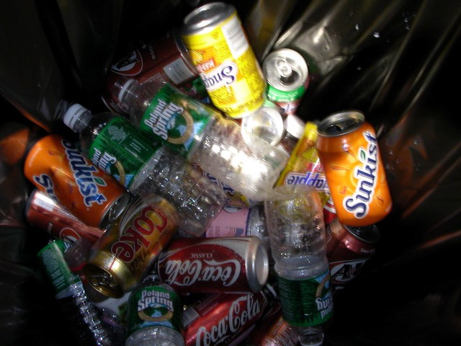
Beverage Containers - Glass, aluminum, and plastic (#1 PET plastic) bottles from soft drinks, water, and beer are commonly found in special event
waste. While some events prohibit beer, or only allow beverages to be sold as “fountain drinks” in paper or plastic cups, bottles and cans find their way into the waste stream. Many attendees bring these containers in backpacks; vendors keep their own supply to quench their thirst; and if camping is permitted at the event, bottles and cans will inevitably be present in that waste too. Depending on local recycling programs or services offered by haulers, beverage containers may be able to be combined (“commingled”), or they may need to be segregated before they are sent to a recycling center or facility.

HCS Flower Show, New Hampshire

Returnable Bottles and Cans - Eleven states, including Maine and Vermont, have “Bottle Bills” or deposit systems that provide a financial incentive (typically $.05 per container) for collecting and recycling beverage containers.⁴ While the materials used to make these containers are identical to other non-redeemable bottles and cans, it is useful for event organizers to consider them separately to maximize the economic benefit from their collection.

Since data on the amount of returnable beverage containers recycled at each event was not obtainable, approximations on the amounts of beverage containers generated at the events were recorded. At the Maine and Vermont events, the returnable beverage containers averaged 11 percent (by weight) of the waste generated at the events. In New Hampshire, a non-Bottle Bill state, beverage containers totaled 9 percent (by weight) of the waste generated.
Recyclable Glass, Plastic and Metal Containers - In addition to beverage containers, significant amounts of glass, plastic, and metal food containers are found in special event waste. These materials are generally from food vendors. In most communities, these materials are easily recycled. However, these containers are likely to be coated with food waste, such as mustard, grease, tomato sauce, etc., and may need to be rinsed before they can be recycled. In general, the two types of plastic containers that are most often recyclable are opaque or tinted HDPE (#2) containers, and clear PET (#1) containers. (Numbers indicating the type of plastic resin used in the container are located on the bottom of the container.) In some recycling programs, as with beverage containers, food containers may be able to be combined or commingled in one recycling bin, or they may need to be separated before being received at a recycling center or facility.

⁴ A list of Bottle Bill states and a summary of the containers, deposits, and other issues addressed in their laws can be found at: http://www.bottlebill.org/.

ORGANIC WASTE
Food Waste - Special events and food go hand-in-hand - fried dough, corn on the cob, hot dogs, and soft drinks, etc. And where there is food, there tends to be food waste. Food waste includes preparation-waste or leftover/unsold food from vendors, as well as plate scraps from attendees.
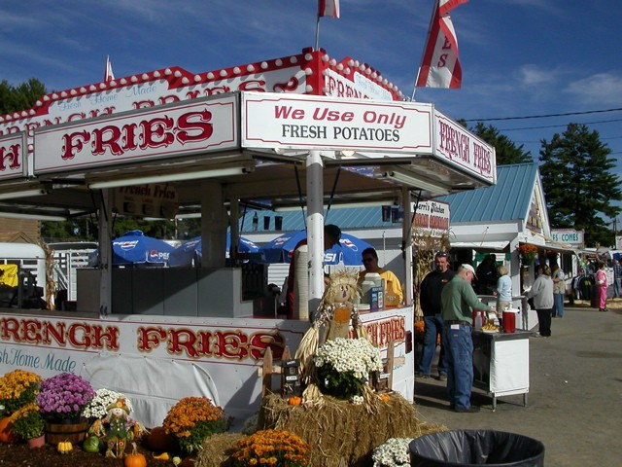
Capturing food waste for possible consumption by people or animals, or diverting it for composting, represents significant waste reduction opportunities. These are also among the most complex efforts to initiate and may require the greatest planning and care in implementation.
Serving Packaging - Where there is food waste, there is also serving packaging (e.g., plates, cups, bags, and cutlery). For the purposes of the conducted waste characterization studies, serving packaging referred to products that attendees use to eat food with, but not the packaging in which the vendors receive the food.
Deerfield Agricultural Fair, New Hampshire

During this project, we found that it was not feasible to separate the food waste from the serving packaging. At each of the six special events, the largest component of waste was food and serving packaging. In fact, on average, food and serving packaging represented 41 percent of the sorted waste by weight. Please note: Waxed or plastic coated packaging has very limited potential to be recycled. It may be composted, if it is specifically made out of biodegradable materials such as paper or cornstarch.

Grease and Cooking Oils - Food vendors preparing and selling fried dough, French fries, onion rings, and other fried foods generate grease and cooking oils that can and should be diverted from the waste stream. While the total amount of grease and cooking oils is not significant from a weight perspective, it is a very important waste to address to avoid improper handling--dumping on the ground, pouring down drains, or being disposed in dumpsters. In some areas, there are rendering companies that will provide barrels for grease collection. The
grease is then used to make new products (e.g., animal feed supplements, soap, cosmetics, and plastics). There is also a growing market for used cooking oils and grease as a component of “biodiesel,” a fuel source that can be produced from vegetable oil and grease.
Animal Waste - Agricultural events that showcase animals create substantial animal waste. Cow, horse, goat, sheep, rabbit, goat, and chicken bedding, and manure are all compostable.
Vegetative Waste - Flower shows and other events often have

vegetative waste – flowers, greenery, trees – that can be composted or chipped for mulch.
Tunbridge World’s Fair, Vermont

BULKY WASTE
Wood Waste - Wooden pallets, crates, and dimensional lumber used for displays and booths are commonly found in the waste at the end of events. These materials can be diverted for reuse or chipped for mulch, bio-mass fuel, or for composting.

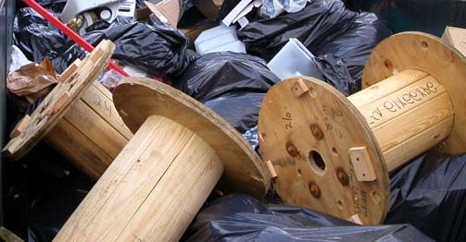
Scrap Metal - Various metal objects were found in the waste at the six events, including electric motors, fencing, sheet metal, car parts (particularly if there is a demolition derby), cooking implements, and copper piping. These objects are often heavy (and thus expensive to dispose of) and/or valuable as a recyclable material, and thus worth the effort to separate from the trash.

Discarded wood spools – Stowe Celebrates Summer, Vermont
Bulky and Orphan Materials – Bulky and orphan materials refer to items like

couches and chairs, carpets, mattresses, suitcases, etc. These wastes may not be generated at the event itself, but get left at the event facility and become the responsibility of the event organizer. In some cases, there are reuse opportunities for these wastes, but they generally require disposal.

OTHER WASTE
Many other fascinating (and not so fascinating) objects are commonly found in the waste stream at special events. Some of the items spotted in the waste sorts at the pilot events include:
Dangerous waste - Needles, medicine and drugs, blood contaminated bandages or clothing, broken glass, knives, other harp objects.
Regulated waste - Automotive oil, oil filters, fluorescent light bulbs, mercury-containing switches, batteries.

Amusing waste - Toys, clothing, money, keys, spent sparklers, pom-poms.
Nasty waste - Diapers, greasy food, dog feces, rags.
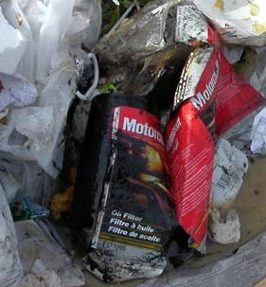
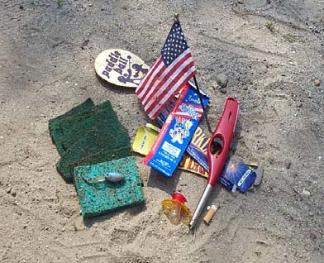
Discarded motor oil and oil filter (left) and discarded toys, lighters, etc. (right) Deerfield Agricultural Fair, New Hampshire

The Dollars and Cents of Waste Management
Getting a handle on the cost of waste management may take some investigative work, yet it is a critical component of controlling costs and finding opportunities for savings. Appendix C provides a sample recycling budget form for your reference. Since organizers need to manage the waste generated at the events, the additional task of implementing recycling will blend in with those waste management efforts. Following are some details on costs and savings that can be anticipated in special event recycling budgets.

COSTS
Costs generally fall into the categories of supplies, labor, contracted hauling services, and disposal.
Supplies - Materials that may need to be purchased or rented include barrels or bins for collecting recyclables from attendees and vendors, recycling signs and fliers, plastic bags to be used as inserts in the recycling bins, and fuel for transportation when emptying the recycling bins within the fairground.
Labor - Labor will be essential for setting up, monitoring, emptying, and removing recycling barrels or bins, and transporting containers to centralized containers or trucks for emptying, as well as assisting with recycling program signage and public education. This area represents an opportunity for utilizing volunteers’ assistance.
Contracted Hauling Services - Costs associated with services provided by waste haulers include container (dumpster) rental, delivery (or “pull”) charges for removing the trash from the fairground, fuel surcharge, and disposal fees (based on the tons of waste needing disposal).
Disposal - If a hauler is hired, the disposal costs are likely to be part of the fees paid to that company. However, if event staff or volunteers haul the waste to the disposal site, the disposal fees will be charged at the disposal facility. In most cases, waste is charged on a weight basis (tons or pounds).

REVENUE/SAVINGS
Avoided Disposal Costs -“Avoided disposal cost” is a term used to represent the amount of money that you ‘SAVE’ by NOT disposing of recyclables as trash. As noted above, many haulers charge customers a disposal fee for each ton (or pound) of waste that they need to dispose of. Thus, it is important to include the avoided disposal cost as part of the savings that result from recycling. For example, if ten tons of cardboard is recycled, and the hauler charges $75 per ton to dispose of trash, then the avoided disposal cost is $750 (10 tons x $75/ton).
NOTE: Some haulers are less precise in applying disposal fees. They may estimate the number of tons in a dumpster rather than actually weighing the material. As a result, you might not get credit for reducing the amount of waste disposed. Work closely with your hauler to ensure correct accountability, and be sure to ask how the weights you pay for are calculated. If possible, check how full the dumpster is before it is taken away. If it is only partially full, this could indicate that a smaller dumpster can be used next year, which should result in a decreased rental and disposal fee. Being a careful waste service consumer may help you save waste disposal costs!
Revenue - Opportunities for generating revenue from waste management strategies include: deposits on returnable containers; and scrap value for recycled paper, cardboard, bottles and cans, and grease.

The Recycling Plans developed for the six participant events include cost and saving information. As a percent of total spending on an event, waste disposal tends to be small. As a result, the potential savings also represent a small percent of overall operating costs. However, many events implemented recycling strategies that required no additional costs, and in many cases netted them significant revenue.

Estimating the Environmental Benefits of Recycling
In addition to understanding the financial implications of a recycling program, it is important to consider the environmental impacts. This will help to prioritize recycling activities and to promote the environmental benefits to participants, vendors, and the public. Following is a list of facts about recycling that can be used in conjunction with data from your event to describe the overall environmental benefits of your recycling program. ⁵

    - Each ton of paper recycled saves 17 trees, 380 gallons of oil, three cubic yards of landfill space, 4,000 kilowatts of energy, and 7,000 gallons of water.
    - Making recycled paper instead of paper that has no recycled content uses 64 percent less energy and uses 58 percent less water.
    - One tree can filter up to 60 pounds of pollutants from the air each year.
    - Every ton of recycled steel saves 2,500 pounds of iron ore and 1,400 pounds of coal.
    - Recycling one aluminum can saves enough energy to run a television or operate a computer for three hours.
    - Every glass bottle recycled saves enough energy to light a 100-watt light bulb for four hours.
    - Half of all the polyester carpet manufactured in the United States is made from recycled plastic bottles. It takes five two-liter plastic bottles to make one square foot of carpet.

Note: Appendix D includes additional facts on average weights for different volumes of various waste materials. Appendix E shows how environmental benefits can be used in outreach materials.

The Nitty Gritty – Organizing Recycling Program Details

Getting Commitment from the Top
The key ingredients to a successful event recycling program are to have a Recycling Plan (it need not be complex), and the full support of the event leaders and the local recycling program. Having these three components makes it possible to integrate recycling efforts into the overall event plan.

In making the case to recycle at an event, it is necessary to emphasize the reasons for conducting a recycling program. Be prepared to address possible concerns or questions that the board of directors, event organizer, or solid waste manager may have related to a recycling program. Some positive attributes of a recycling program include:

    - The event is a community showcase and an important forum to demonstrate environmental leadership.

⁵ Many of these facts are commonly cited in recycling publications. One source for these and other recycling facts is Earth911. Another site with more detailed descriptions of the environmental benefits of recycling is http://www.epa.gov/epaoswer/non-hw/muncpl/faq.htm#5

    - A well-planned recycling program can help to reduce costs, while improving the environment, and creating a positive image for the event.
    - The event generates a lot of waste, much of which can be reduced or recycled.
    - Recycling at special events can also be used as an educational opportunity to engage the public.

Some common questions that are useful to anticipate include:
    - Why hasn’t recycling been part of the event in the past?
    - Will recycling distract already busy staff and volunteers from the primary mission of hosting putting on a fun and well-organized event?
    - How much extra time will our volunteers or staff have to spend collecting, sorting, or moving recyclable materials?
    - What additional costs will there be for separate containers, signs, waste collection, and removal?
    - Will recycling containers create a cluttered or messy look?
    - Will there be odors or nuisances?
    - Will our “regular” hauler (who might be a friend or relative of the event organizer) be impacted by the recycling program?
    - Are there any liability issues associated with the recycling program?
The following section will help to answers these questions. Referencing successful recycling programs at similar special events is a useful strategy for demonstrating what can be done and its impacts.

Designating a Point Person / Steering Committee
Once there is commitment to proceed, it is important to have a point person who will create and oversee implementation of the Recycling Plan. Ideally, the point person will have an interest in the recycling program and have a desire to make it succeed. If that is not the case, extra effort will be needed to ensure that the point person is held accountable for completing these tasks. Be sure the point person has the resources to succeed, including: time, attention from decision makers, and commitment from the top.

In some cases, it makes sense to have a recycling committee to help the point person identify opportunities and resources. These individuals may be part of the event organizing body, from a civic group, or a local recycling organization or agency. Typically, the point person will need to be the driving force to make the recycling program succeed.

Creating a Realistic Plan
As noted above, a recycling program does not need to be complicated. Recycling Plans for the six participant events show how events of different sizes and types addressed recycling opportunities. Following are web links to these Plans:

Bath Heritage Days, Maine

Clinton Lions Club Agricultural Fair, Maine

Deerfield Fair, New Hampshire

HCS Flower Show, New Hampshire
Stowe Celebrates Summer, Vermont
Turnbridge Agricultural Fair, Vermont

Following is a sample Recycling Plan, which details the key components.

SAMPLE RECYCLING PLAN

Goal
For the event to be a showcase of how waste may be managed in an environmentally responsible manner, reducing and reusing as many materials as is economically and logistically feasible.

Program Management
Name, Waste Manager and chair of the event recycling committee - reports to Executive Director, and needs to connect with local professionals and public programs. Name (if different from the Waste Manager), Recycling Plan Manager – reports to the Waste Manager or recycling committee, and manages each component of the Recycling Plan.

Targeted Waste
Cardboard boxes and aluminum soda and beer cans.

Collection and Hauling System
Cardboard - ABC hauling company will place a labeled cardboard dumpster (10 cubic yards) with a lid next to the labeled waste dumpster. The waste dumpster will be 20 cubic yards, which is 10 yards less than last year. Vendors will bring empty cardboard boxes to the designated dumpster. ABC hauling company will remove the dumpster at the end of the event.

Aluminum Soda and Beer Cans - Ten garbage cans will be designated as recycling bins for the cans. The bins will be spray painted blue with white letters that say, “ALUMINUM BEER & SODA CANS ONLY”. A round plywood top with a small hole will be placed on each blue bin. The bins will be located next to garbage cans in the food court. Clear plastic bags will be placed in the recycling bins. The garbage crew will pull full bags and place them next to the cardboard dumpster. (This should not increase the garbage crew’s burden since the increase in recyclables means less trash to be collected.) Volunteers will bring full bags to the recycling center at the end of each day.

Materials/ Supplies
- Cardboard dumpster – order from ABC hauling company
- 10 garbage cans
- Plywood tops for each garbage can
- Spray paint and stencil that says “ALUMINUM BEER & SODA CANS ONLY”
- Clear plastic (biodegradable, if possible) garbage bags

Labor
Organizers

  - Paint and stencil recycling bins
  - Cut out plywood tops for recycling cans
  - Track amounts of trash and recyclables generated
Staff or Volunteers
  - Place recycling bins around event grounds
  - Drive truck of plastic containers to recycling center (30 minutes x 4 days)
  - Clean recycling bins and store
Vendors
  - Separate cardboard from trash

Communications
- Add a special note in letter to vendors about event’s recycling program
- Label aluminum can recycling containers with appropriate recycling sign
- Put a note in the event flyer asking attendees to recycle aluminum cans

Costs
- Cardboard dumpster – delivery and rental = $100 (no charge for disposal)
- Other costs (plastic bags, spray paint, wood for tops, gas for truck) = $25
- Total costs = $125

Savings from Avoided Disposal Cost: The difference between the cost of recycling 10 cubic yards (5,000 pounds = 2.5 tons) of cardboard and the disposal is the avoided disposal cost. Assuming the cost of disposal is $60/ton, the avoided disposal cost equals $150 (2.5 tons x $60/ton).

Net Savings: The net savings of recycling 10 cubic yards of cardboard equals $25.

Negotiating with Haulers
Negotiating with haulers is not unlike dealing with other service providers. There are a few common practices to help you get the right service at a fair price.

- Know your waste and management options. If you have a record of the amount of waste generated in past years (tons or cubic yards are the most common measurements), you are well on your way. Also, find out what disposal and recycling facilities, such as the ABC recycling company and town recycling center, are accessible and available for the event’s waste. And if you have no record from past events, start one with this event by looking for the appropriate services in the local newspapers or telephone book.

- Speak their language. By using terms common in the waste industry, you will be able to speak the same language as the hauler, and comparison shop. Following are a few key terms to know (or questions to ask).
  - Tipping Fee (also disposal fee) is the fee that the hauler charges based on the amount (usually tons) of material that is disposed of (or tipped) at the landfill, transfer station or incinerator.
  - Pull Charge (also hauling of filled container charge) is the charge for removing the dumpster.
  - Rental Fee is the cost of using the dumpster for a specified length of time.
  - Cubic Yard (or yard) is the most common unit for measuring the volume of solid waste. A cubic yard is equivalent to 202 U.S. gallons.

  - Tons are the most common measure of weight for waste materials – a ton is equal to 2,000 pounds.
  - Density of waste refers to the weight per unit of volume (e.g., the estimated weight of food waste is 412 pounds/55 gallon drum). (See Appendix D for densities of various waste materials.)
  - Dumpster (also container, box or can) is a large container for storing trash. Dumpsters are sized by the cubic yard, and can range from 1 yard to 40 yards.
  - Compactor is a dumpster with an internal mechanism that compacts the waste to allow for more material to be stored in a single unit. These are commonly used for cardboard.
  - Toter Carts are wheeled containers for trash or recyclables, typically holding 60 to 100 gallons.
  - Commingled is a term used to describe unlike recyclables collected in a single recycling bin. Commingled containers often used for aluminum, plastic and glass, and food and beverage containers.
If you are not sure about a term, don’t be afraid to ask. This will allow you to compare apples to apples, and you will know it for next time.

- Speak with local haulers and recyclers to get several bids. Given the consolidation in the trash industry, this is not always possible. Where there is competition, it makes sense to shop it. Don’t just rely on last year’s pricing. If using the same company as last year and not seeking bids, be sure to ask for updated pricing.
- Get price details. Ask for a breakdown of the charges--dumpster rental, removal (or pull charge), and disposal fee (tipping fee), and how the disposal fee is determined.

- Understand recycling requirements. For example, is it acceptable for glass, metal, and plastic containers to be commingled, or do they need to be segregated? Do food containers need to be rinsed before being recycled?

- Explore service options. Look at the cost of cardboard recycling and disposal, or just cardboard recycling. Usually, it is easier and as cost effective to use one hauler for all services, but not always. Sometimes a company only provides recycling or trash service, and may offer better prices on that specific service. Also, it is good to know if the company provides recycling containers, signs, or any other services.

- Ask for results. After the event, ask the hauler for a report of the total tonnage or cubic yards of the materials removed for recycling and disposal. Keep track of this data for next year’s planning, and ask the hauler for recommendations on improving the program and decreasing costs in the future.

Dealing with Event Vendors
Vendors are responsible for a considerable amount of waste generated at events and can play an important role in the recycling program.

STRATEGIES FOR VENDOR PARTICIPATION
Cardboard Recycling – Require vendors to bring flattened cardboard boxes to a central location for recycling (e.g., cardboard dumpster). Focus on the early stages of the event when most boxes are opened and emptied.

Food and Beverage Container Recycling – Provide vendors with appropriately sized recycling bins for the materials they generate, as well as for their customers. Vendors may have restaurant-size cans and jugs that can be recycled.
Grease or Cooking Oil Collection – Require vendors to empty grease into centralized collection containers.

Food Waste Composting – Require vendors to use only biodegradable dishes, cups, flatware, and plastic bags.

Trash Removal – Limit allowable waste from vendors, or require that they remove all waste from the site upon departure.

Wood Waste – Require vendors to remove all wood waste or bring it to a centralized location for recycling.

COMMUNICATION IS THE KEY
Be clear and consistent with all vendor communications to ensure that expectations are understood, and that all vendors are treated alike. This is particularly important if a vendor has been working at the event for a number of years and may view recycling as a new or additional responsibility.

Possible communication strategies include:
  - Stipulating the recycling requirements in vendor contracts, and making sure that new requirements are visually highlighted and orally pointed out.
  - Sending each vendor a letter of instruction, in advance of the event, to remind them of the requirements.
  - Passing out an instructional flier at each vendor booth or include one with the vendor check-in materials (See sample in Appendix E.).
  - Asking a volunteer or staff person to speak with each vendor, during set up, about the program requirements; and answering any logistical questions that may arise.
  - Clearly labeling all recycling containers and collection locations.
  - Designating someone to be available to vendors to answer their questions.

Equipment and Containers
Recycling containers at special events fall into several categories, and for each there is a wide range of options ranging from low- or no-cost items to specialty products.
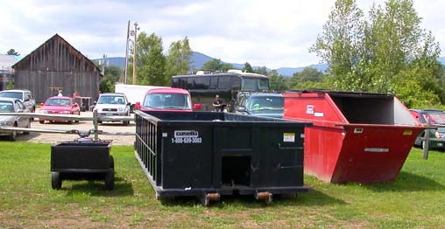
Centralized Containers/Locations - Centralized containers are often used for garbage, and make sense for recyclable materials as well. These containers are not intended for use by the public, but are for staff, volunteers, and vendors. They may include dumpsters or containers for cardboard boxes, and centralized areas or containers for storing bags of recyclable cans and bottles, as well as wood waste. It is important to make sure
Dumpsters at Stowe Celebrates Summer, Vermont

these materials are picked up and removed at the end of each day, so they don’t become unsightly.
Recycling Cans or Bins for Attendees - Ideally, there will be a clearly marked recycling bin (e.g., for bottles and cans, and paper) located next to every garbage can for attendees to use. At a minimum, there should be recycling containers for beverage containers located in the areas where most drinks are served and consumed, as well as at the entrances and exits. Recycling containers for program fliers are also effective when placed near the exits. The goal is to make recycling easily accessible and convenient to encourage attendees’ full participation.

It is not necessary to buy special containers for recycling. Brightly painted garbage cans with stenciled signs are a low-cost option for recycling. Another option would be to purchase or lease specialty-recycling containers like those on the next page.

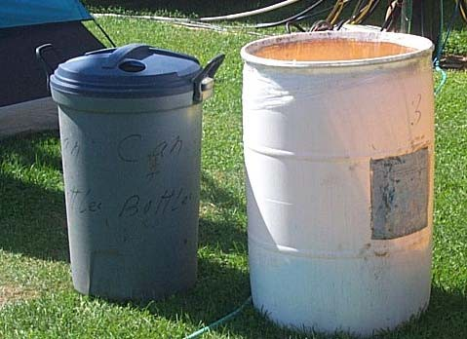
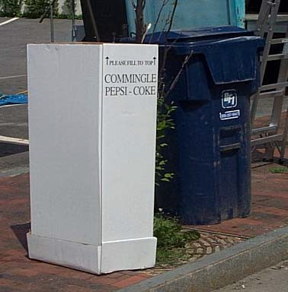
Recycling Containers used at Clinton Lions Club Agricultural Fair, Maine

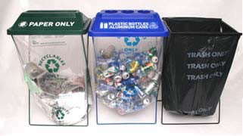
“Bag in a Box” recycling container donated by local beverage distributors at Bath Heritage Days, Maine
Clearstream Recycling21Containers can be found at http://www.clearstreamrecycler.com/recycling_center.asp

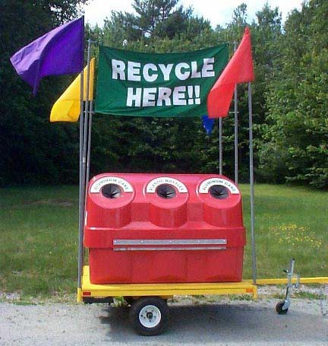
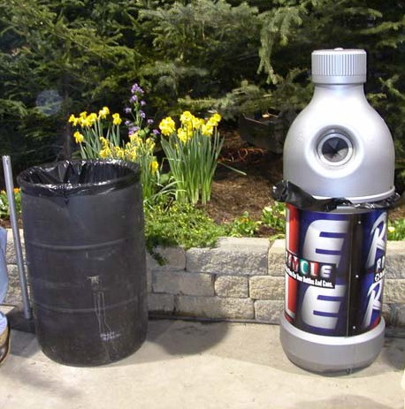
Some state recycling programs or fair associations provide recycling containers to special events at no charge, except for the cost of transporting them to and from the event. Contact your state fair association member to inquire if containers are available.

Borrowed beverage recycling container from the NH State Fair Association – HCS Flower Show, New Hampshire

Signage and Communication

RecycleMobile, Northeast Resource Recovery Association (NRRA) http://www.recyclewithus.org/recyclemobile.html

Recycling containers must be clearly marked, and should have a unique look, readily distinguishing them as recycling containers and not as trash containers. Signage should be visible, legible, durable, rain-proof, and if possible, reusable for next year.

Staff and Volunteers
During the planning process, determine how many people will be needed to implement the recycling program. Conversely, if there is a set number of staff, think about how best to use their time. The goal is to integrate recycling efforts with garbage collection and management so it doesn’t require extra staff or volunteer hours.

It is critical that all staff and volunteers be educated and trained on their roles and tasks, including what materials are unacceptable with recyclables. Potential roles for staff and volunteers include:

    - Acquiring or preparing recycling containers (e.g., transporting, buying, removing from storage, painting, fixing, etc.);
    - Placing containers around event grounds prior to start of event;
    - Emptying full containers into a cart (or removing full bags and replacing with empty bags) and delivering to central storage location;
    - Transporting recyclables to a recycling center or other location;
    - Cleaning, returning, or storing containers at end of event;
    - Helping vendors comply with the recycling program, and
    - Tracking amount of waste and recyclables generated.

Some possible sources of volunteers include:

    - Recycling groups,
    - Civic groups,
    - Church groups,
    - Youth groups,
    - Municipal recycling committee,
    - Solid waste district, and
    - State recycling organization.
As with other aspects of special events in which volunteers are used, it is important to:

    - Have reasonable expectations of volunteers, especially if they want to attend the event;
    - Confirm all volunteer commitments before the start of the event;
    - Recognize that volunteers sometimes do not show up and plan accordingly. As a general rule, it is best to recruit more volunteers than needed for the day;
    - Give the volunteers something in return - recognition, free pass to the event, T-shirt, thanked in event publicity, etc;
    - Thank volunteers each day and ask if they will come back the next day;
    - Recognize the value of partnerships established in support of these events as well; and
    - Thank volunteers again!

Leveraging Partnerships
You don’t have to be alone in implementing the event Recycling Plan. Many types of entities share an interest in establishing and supporting recycling at special events, and may be able to help. To maximize the potential that these organizations offer, it is important to be creative, contact them early in the planning process, and think about what assistance is needed. For example:
State Fair Associations may be interested in helping to organize workshops at their conferences to discuss recycling opportunities at special events. The New Hampshire State Fair Association purchased recycling bins for loan to special events throughout the state.

Local businesses may be interested in helping to underwrite a recycling effort, or provide or loan recycling bins and signage.

Recycling organizations are often interested in recruiting volunteers for a recycling program and in providing recycling educational materials, and information at a booth or for an event publication.

Recycling businesses, such as curbside recycling collectors, cardboard recyclers, or redemption centers in states with a Bottle Bill, may help to provide free or discounted services or containers as a promotional activity. Oftentimes, private businesses are willing to sponsor the cost of recycling containers, in exchange for their logo being on the containers.

State and local recycling agencies may offer technical support, equipment, or grant money to help special events run recycling programs.

Event Management and Evaluation – Implementing the Plan & Taking a Look Back

Point Person
Just as it is critical to have a lead person for the recycling program planning, it is also essential to have a single person in charge of implementing the Recycling Plan. Ideally, the lead planning and implementation roles will be filled by the same person. If a different person takes charge during the implementation stage, try to ensure that information and plans are well communicated during the transition. Regardless of the avenue selected, having a recycling committee to provide guidance and continuity, as well as assistance, to the program is strongly recommended.

Set Up
The days before the event are key times to hammer out last minute details, prepare materials, remind staff and volunteers of their roles, and confirm arrangements with vendors and waste haulers. A few items to put on your check list for the days leading up to the event include:

- Confirm delivery and pickup times and locations of dumpsters with hauler.
- Review trash and recycling handling logistics with staff.
- Contact volunteers, or volunteer coordinators.
- Inventory containers, signs, and other materials.
- Remind vendors, as they set up, about their responsibilities for recycling and waste management.

During the Event
Like other aspects of special events, once the event begins, it has a life of its own and making major changes to plans are essentially impossible. However, some variables (e.g., weather, turnout, and absent volunteers or staff) may affect the program on the day of the event, and being on top of recycling details is important.

- Have a roster indicating who is to do what, where, and when.
- Have a walkie-talkie, phone, or a contact place (such as the event’s recycling booth) so staff, volunteers, and vendors may easily speak with the lead person.
- Walk or drive (or ride a bike) around the event periodically, checking on how full garbage and recycling cans are, litter problems, whether signs are in place, and other logistics--constantly manage the flow of trash and recyclables. If need be, relocate containers (let others know of any changes) or signs.
- Check on dumpsters and recycling containers to see that they are being used correctly. Notify vendors, staff or volunteers if there is a noticeable problem (e.g., garbage in the cardboard bin, or lots of cans and bottles in the garbage).

After the Event
In addition to putting up your feet, take a moment to evaluate how the event went, wrap up loose ends, thank participants and vendors, and think about improvements for next year. Some things to do after the participants leave:

- Collect, clean, and store recycling bins or return them if borrowed or leased.
- Collect and store reusable signs.
- Document the amount of garbage sent out (get data from hauler) and the amount of recyclables recovered (estimates from staff or volunteers or data from haulers).

- Evaluate how “clean” the recyclables were, and how free of recyclables the trash was. This will provide information for developing future strategies to improve recycling or to change the number and size of containers and signage for the Recycling Plan.
- Identify additional target materials to reduce, reuse, or recycle in the future.
- Discuss recycling and waste management efforts with staff, vendors, property owners, and haulers. What worked? What didn’t? How can the program be improved for next year? How can it be easier for everyone to participate? What were the costs or savings?
- Thank everyone for his or her participation, especially the volunteers!

Publicity and Education
Special events provide a rich opportunity for promoting recycling and recycling efforts, as well as promoting the event’s environmental leadership. This opportunity should not go unused! Plan an educational and informational campaign for the public, well in advance of the event. Here are a few suggestions for publicity and education:

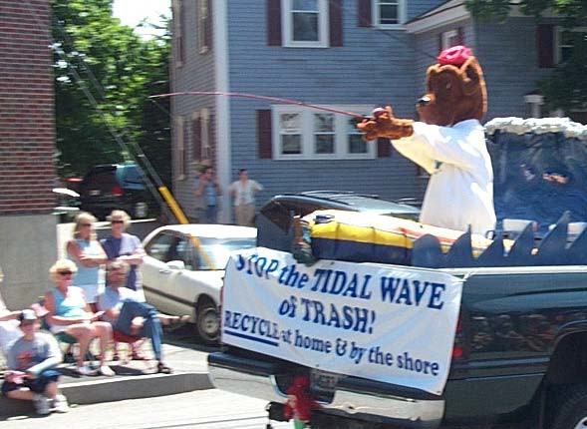
- Write and distribute press releases about the event (before and/or after) to local press. (See Appendix F for sample.)
- Involve local recycling program and staff in this effort.
- Involve the hauler(s) selected to provide removal and recycling services.
- Set up booths at the event to promote recycling activities in the community and at the event. These booths may be staffed by recycling organizations.
- Display signage and posters around the event to help encourage and inform vendors and participants about what they can recycle and where.
- Post information about the event’s recycling on the event’s or town’s website.
- Develop event brochures with details on the event’s recycling efforts and opportunities for
vendors and participants to recycle. Rudy the Recycling Dog – Bath Heritage Days, Maine


Recycling note in event brochure - HCS Flower Show, New Hampshire

Frequently Asked Questions
As with any new initiative, a recycling program will generate questions from a variety of sources, including event management, staff, vendors, and attendees. Following are some of those questions and a few possible responses. Each event will generate unique questions and responses will have to be tailored to that situation.

Will recycling distract already busy staff and volunteers from our main mission of putting on a fun and well-organized event?
With proper planning, recycling efforts can replace some waste management efforts, not add time and energy. Still, any new effort requires some start up effort. If this is of concern, focus on one or two small efforts in the first year, and assess the impacts on staff and volunteer resources and the benefits of the recycling program to the event.

What additional costs will there be for containers, signs, waste collection, and removal?
By following the suggestions in Section II, D. The Dollars and Cents of Waste Management, it is possible to estimate the costs and/or savings that the program will entail. By focusing on the materials with the greatest benefit for waste reduction and least cost for handling, it is possible to have a no- or very low-cost recycling program.

Will recycling containers create a cluttered or messy look?
Site-specific planning will make it possible to prevent the recycling bins from being unsightly. Consider different container types and signs that fit in with the event design theme. Since recycling containers should always be next to trash containers, and are frequently the same size as a trash container, they are unobtrusive. Recycling containers are becoming more common in public space and attendees are likely to see the addition as an attraction rather than a problem.

Will there be any additional odors or nuisances?
There should not be any new or additional odors introduced by recycling. In fact the recycling containers will create less of a nuisance and odor than mixed garbage. If food waste is being collected, it should be kept in lidded containers.

Will we have to switch garbage companies (haulers)?
Not necessarily. Many waste haulers offer recycling services, or will offer them if asked. Nevertheless, researching the costs and services provided by different local companies will help to ensure the best value and service.

Will we lose vendors if we require them to recycle or take away their trash?
Not if the organizer’s expectations are clearly expressed and reasonable. Most vendors will not mind being asked to participate in the recycling efforts and are requested to put waste in a specific dumpster or barrel, as long as all the other vendors are doing the same. Requiring vendors to take trash back with them is a strategy that needs to be used selectively. It makes sense to talk with a few vendors to get their reaction on what is reasonable and suggestions for implementing and communicating new initiatives.

Is there any liability associated with a recycling program?
There is no difference between recycling or waste management programs from the perspective of liability. However, any waste management activity can be dangerous. Lifting heavy containers, getting cut by sharp objects, and being exposed to hazardous or infectious materials, are some of the most common concerns. Education of volunteers should include more than instructions on recycling. Take the time to teach them safety measures. By following common safety protocols (e.g., not lifting more

than 50 pounds, wearing protective gloves, and being careful) risks can be minimized. Also, the less material that is directly handled by staff or volunteers, the less chance of injury there will be.

How much extra time will it require to set up and run the recycling program?
The extra time will be in the initial program design and in ensuring that the necessary services and equipment will be available and affordable. During implementation, the recycling program efforts should blend in with other waste management efforts. The more recycling is implemented at the event, the easier it becomes for the organizers, vendors, and attendees. Yet, it is important to be realistic and to identify and review all the steps involved each year. It makes sense to have vendors directly recycle as much as they can, and for volunteers to work on providing program support.

We (vendors) are so busy getting set up for the event, now you want us to separate our trash too?
You will have to decide what role you want vendors to play in the recycling program. Focus on activities that make the most sense for them to help with (e.g., recycling cardboard and used grease). Planning the location of recycling containers near solid waste dumpsters will minimize the perception of additional burden created by separating recyclables out from trash.

APPENDICES

- Selected Events Summary

- Recycling Planning Work Sheet
- Recycling Budget Form

- Helpful Resources & Links

- Sample Recycling Sign
- Sample Press Release

Appendix A: Selected Events Summary

SELECTED EVENT PROFILES
Following are brief summaries of the six events that were involved in the development of this Guidebook. There were two events each in Maine, New Hampshire, and Vermont; with one of the events in each state being an agricultural event.

Event | Bath Heritage Days
Location | Downtown Bath, Maine
Organizer | Bath Maine Street Organization
Staff/Volunteers | Volunteers and Bath Main Street Staff
Dates | July 1 – 4, 2005 (Fri, Sat, Sun, Mon)
Total Estimated Attendance | 50,000 to 100,000
Non-food Vendors | 29
Food Vendors | 36
Waste Generated | 16,187 pounds
Materials Recycled | Cardboard, returnable bottles and cans
Web site | http://www.visitbath.com/heritagedays/

Event | 52nd Annual Clinton Lions Agricultural Fair
Location | Clinton, Maine
Organizer | Clinton Lions Club
Staff/Volunteers | Over 300 volunteers
Dates | September 8 -11, 2005 (Thurs, Fri, Sat, Sun)
Total Estimated Attendance | 17,000
Non-food Vendors | 35-40
Food Vendors | 12 food
Waste Generated | 6,790 pounds
Materials Recycled | Cardboard, returnable bottles and cans, grease
Web site | http://www.getrealmaine.com/visit/maine_fairs.shtml

Event | 129th Deerfield Agricultural Fair
Location | Deerfield, New Hampshire
Organizer | Deerfield Fair Association
Staff/Volunteers | 11 Superintendents, other staff and volunteers
Dates | September 29 – October 1, 2005 (Thurs, Fri, Sat, Sun)
Total Estimated Attendance | 120,000
Non-food Vendors | Unknown
Food Vendors | Unknown
Waste Generated | 150,000 pounds
Materials Recycled | Grease
Web site | http://www.deerfieldfair.org/

Event | HCS Breath of Spring Flower Show
Location | Cheshire Fairgrounds; Swanzey, New Hampshire (in ice skating rink)
Organizer | Home Healthcare, Hospice and Community Services (HCS)
Staff | Cheshire Fairgrounds management and staff (1 to 3 people per day)
Dates | April 1 – 3, 2005 (Fri, Sat, Sun)
Total Estimated Attendance | 6,720 people
Non-food Vendors | 50
Food Vendors | 6-8
Waste Generated | 7,034 pounds
Materials Recycled | Cardboard, bottles and cans, flower pots, vegetative waste
Web site | http://www.hcsservices.org/flowershow/

Event | Stowe Celebrates Summer
Location | Stowe, Vermont
Organizer | Craft Producers, Inc.
Staff | Provided by Craft Producers, Inc.
Dates | July 29 – 31, 2005 (Fri, Sat, Sun)
Total Estimated Attendance | Not reported
Non-food Vendors | 135
Food Vendors | 30-40
Waste Generated | 2,889 pounds
Materials Recycled | Cardboard, bottles and cans
Web site | http://www.craftproducers.com/

Event | 134th Tunbridge World’s Fair
Location | Tunbridge, Vermont
Organizer | Tunbridge World’s Fair Association
Staff/Volunteers | 10 staff
Dates | September 15 - 18, 2005 (Thurs, Fri, Sat, Sun)
Total Estimated Attendance | 50,000
Non-food Vendors | Unknown
Food Vendors | 40
Waste Generated | 45,000 pounds
Materials Recycled | Bottles and cans
Web site | http://www.tunbridgefair.com

SELECTED EVENTS’ WASTE GENERATION
The following chart depicts the percentages of waste generated at each event. These numbers should be taken as approximations. While an effort was made to obtain random samples of waste from each event, this was not always possible. The sample size for the waste characterization analysis at the Tunbridge World’s Fair was low, and thus the figures below could be skewed.
It is clear that food and food serving packaging are significant sources of waste at special events. In addition, cardboard boxes are a very large component of the waste stream, followed by bottles and cans, both redeemables and others that can be recycled.

Waste Generation by Percent

60
&

50

40

Cardboard Paper
Bottles and Cans (
30 Returnable B&C
Food
Food Packaging Other

20

10

0
Tunbridge STOWE Deerfield HCS Clinton BATH

Notes:

- The events named in lower case letters are agricultural events, and those in CAPITAL LETTERS are non-agricultural.
- Food packaging refers to food serving packaging only. For events where no specific food data was obtainable, this category may also include food.
- There is no Bottle Bill in New Hampshire, thus the Deerfield and HCS events have no returnable containers in their mix.

More detailed data exists in the specific Recycling Plans for each event, which may be found on the web at:
- Bath Heritage Days, Maine
- Clinton Lions Club Agricultural Fair, Maine
- Deerfield Fair, New Hampshire
- HCS Flower Show, New Hampshire
- Stowe Celebrates Summer, Vermont
- Turnbridge Agricultural Fair, Vermont

Appendix B: Recycling Planning Work Sheet

General Information
- Event Name
- Event Date(s)
- Event Location
- Who’s in charge of solid waste?

Size of Event
- What is the footprint of the event in acres or square feet?
- How many people generally attend?
- How many vendors attend?
- How many of the vendors sell food?

Waste Generation
How much waste was generated at the event last year (in tons, cubic yards, or other units)?

Take a guess at the amount of each type of waste in your waste stream by percent:
- Cardboard
- Food
- Food serving packaging (plates, cups, utensils, etc.)

- Wood (including pallets)
- Beverage Bottles and Cans
- Other Recyclable Containers
- Paper
- Grease
- Other

Vendor Waste
- Where are vendors supposed to put their waste (e.g., behind their booth, in central dumpster, in garbage cans)?

- Are vendors responsible for packing out their own waste?
- When are contracts with vendors negotiated?
- Are vendors charged a waste disposal fee or is it included in the lease/rental fee?

Participant Waste
- What types of waste containers have been used for participants (e.g., size, material, etc.)?

- How many waste containers have been used?

- Are waste containers leased, borrowed or owned?

- Waste Haulers (Include haulers used in past years and others in the area.)

Company | Contact | Phone | Email

Waste Costs
  - Labor (number of workers x hours x hourly rate/or flat fees)

  - Waste disposal (cost per ton x tons/or flat rate)

  - Container rentals (either large dumpsters or individual containers)

  - “Pull Charges” or the cost to remove full dumpsters

  - Other (bags, etc.)

Recycling Targets
Check all the following materials that would be the easiest and most productive to reduce, reuse, or recycle.
    - Cardboard
    - Food
    - Food serving packaging (i.e., plates, cups, utensils, etc.)
    - Beverage Bottles and Cans
    - Other Recyclable Containers
    - Paper
    - Grease
    - Wood
    - Other

Point People and Contacts
List people and their contact information who would be good candidates to be the point people or to be involved in the recycling committee or effort (Include local recycling organizations, municipal or state recycling agencies, volunteers in community, etc.).

Company | Contact | Phone | Email

Appendix C: Recycling Budget Form

COSTS | Cost /Unit | Units | Total
Materials
Labor
Hauler Services
Disposal
Total Costs
SAVINGS | Value/Unit | Units | Total
Avoided Disposal Costs
Revenue
Total Savings
Net (Savings – Costs)

Appendix D: Helpful Resources and Links

SPECIAL EVENTS WITH ESTABLISHED RECYCLING PROGRAMS
The Common Ground Fair in Maine has one of the most ambitious waste reduction programs of any special event in the country. More than 10 years ago, the Zero Garbage Project was established at the Fair. Since then, hundreds of volunteers have made a heroic effort to recycle or compost everything that is discarded. Food and paper are composted; glass, metal and some plastics are recycled; and deposit beverage containers are redeemed. http://www.mofga.org/fb_12zgb.html

The Lowell Folk Festival in Lowell Massachusetts has an extensive recycling and composting program, and includes an educational element describing how the program works. http://www.lowellfolkfestival.org/recycle.htm

USEFUL WASTE CONVERSION FACTORS

Material | Volume | Estimated Weight (in Pounds)
Cardboard boxes: un-compacted/ flattened | 1 cubic yard | 50-150
Newspaper: un-compacted | 1 cubic yard | 360-505
Mixed paper: flat | 1 cubic yard | 380/755
Glass: whole bottles | 1 cubic yard | 500-700
Aluminum cans: whole | 1 cubic yard | 50-70
Plastic soda bottles: whole | 1 cubic yard | 40
Wood pallets | 1 cubic yard | 515
Grease (fats, solid-liquid cooking oil) | 55-gallon drum | 410
Food Scraps | 55-gallon drum | 412
Municipal Solid Waste: residential/ un-compacted | 1 cubic yard | 150-300
Municipal Solid Waste: commercial/ un-compacted | 1 cubic yard | 300-600
Source: http://www.epa.gov/recycle.measure/docs/guide.pdf (Measuring Recycling:
A Guide for State and Local Governments; page 62: “Standard Waste Volume to Weight Conversion Factors”)

Appendix E: Sample Recycling Sign

Please Help Us to Recycle Cardboard
At Your Fair This Year

PUT ALL DRY CARDBOARD IN THE DESIGNATED CARDBOARD RECYCLING CONTAINER

DID YOU KNOW?
Each ton of recycled paper can save 17 trees, 380 gallons of oil, three cubic yards of landfill space, 4,000 kilowatts of energy and 7,000 gallons of water!
THANKS FOR PITCHING IN!



Appendix F: Sample Press Release
Main Street Bath, the producers of Heritage Days, are beginning the implementation of a recycling plan created through a study conducted by the Northeast Recycling Council, Inc. (NERC), and its subcontractor, DSM Environmental Services, Inc. (DSM). The purpose of this USDA-funded project was to improve special event waste reduction and recycling efforts, particularly in rural communities with populations of less than 10,000.

Main Street Bath/Bath Heritage Days has found partners to begin implementation of the suggestions given to reduce the amount of trash at the annual festival and increase the recycling in an attempt to reduce the amount of waste being brought to the Bath Landfill as well as to help educate the community about the importance and necessity of recycling.

The Children’s School House, an alternative school program with students in pre-school through 5th grade, will design flyers to distribute to the various festival vendors explaining the importance of recycling, what items are being recycled and where to bring the items. “We are excited to utilize the students being practiced in their computer class for a “real life” purpose,” said Kirsti Ryder, founder and one of the teachers in the school, “as well as to promote one of the principles we practice in the school.” Student volunteers, with help from the parents and other teachers, will monitor the event and be available to answer questions. “We’re beginning simple and will focus our efforts on returnable bottles, cardboard and cooking oils.

Chewonki Foundation will be collecting the used cooking oils from the various carnival food vendors to turn into biofuel for their vehicles converted toward this type of fuel. “Add quote about this”
Pine Tree Waste, the contracted waste company for the festival, will be supporting this project with reduced costs for the extra containers necessary for collecting the recycled items.

Bath Landfill will continue their efforts to promote city-wide recycling in this time of crisis. “The usability of our landfill is coming to an end,” reports Leigh Leiner, Head of the Department, “any and all efforts to reduce waste coming in helps.”

More information can be found on this project by visiting www.visitbath.com.

